**Table of Contents**

A. Logging Into the **UConn Scholar/Employee Portal** 1

B. General Overview of Creating an H-1B Beneficiary Sponsorship Request 1

C. Initiate A New Request: 2

D. H-1B Extension 3

E. H-1B Amendment Request 4

F. Upload Required Documents for Departments: 7

# Logging Into the [**UConn Scholar/Employee Portal**](https://isssportal.uconn.edu/index.cfm?fuseaction=scholarPortal.Department#/login)

1. **Use GOOGLE CHROME with the Portal** and go to the [UConn Scholar/Employee portal](https://nam10.safelinks.protection.outlook.com/?url=https%3A%2F%2Fisssportal.uconn.edu%2Findex.cfm%3FFuseAction%3DSCHOLARportal.department%23%2Flogin&data=02%7C01%7Cchristene.cooper%40uconn.edu%7Ca103560e9f8e4ec5e73a08d78fa48595%7C17f1a87e2a254eaab9df9d439034b080%7C0%7C0%7C637135809087801991&sdata=hyeNA8Vyr9NrfgJTvjEqQMXnXIcrrb4%2BbGOmFcnlOxg%3D&reserved=0). Be sure to log in with your NetID and password.

**BEFORE LOGGING IN…  Click the BOX circled in red below where it says**

**“ACADEMIC DEPARTMENT LOGIN”**

# General Overview of Creating an H-1B Beneficiary Sponsorship Request

**A New Sponsorship Request is initiated by a Departmental Admin.**

If the Departmental Admin will begin the process, they must first be properly configured in the Scholar Admin.

After the ISSS Admin has added the Departmental Admin, they will receive login credentials for the Departmental Portal.

Upon logging in, the Departmental Admin dashboard will display with cards representing each Scholar/Beneficiary for whom their department has submitted information.

* **Sponsorship Requests** - Requests have been submitted by the department, but ISSS or LR has not yet determined how to process them
* **Pending Records**- These are Scholars/Beneficiaries are newly accepted requests and are being processed but not yet Finalized they are pending the following final actions:
  1. H-1B has not been approved by USCIS and start date has not arrived
  2. J-1 has not been validated in SEVIS and DS-2019 has not been created
* **Active** - If an H-1B employee, their start date is current and the USCIS Decision has been noted.   
   If a J scholar, their Academic Objective record is in Active status.
* **Inactive** – ISSS/LR determined that these Scholars/Beneficiaries are either not eligible for sponsorship or inactive for multiple reasons.

# Initiate A New Request:

To initiate a new request, the Departmental Admin will click the New Sponsorship Request button, located in the top left corner. **Then search for beneficiary’s name in “Search by Name, Email” field under the “Provide Name of Scholar/Employee” section.** **If the Beneficiary has an existing record in Terra Dotta, and you are changing from F1-OPT or changing from J1, you will need to use a different email address to create a new H-1B profile. This is temporary, until their prior status comes to an end.**

Complete the request form. When the New Sponsorship Request is submitted, an email is sent to the ISSS/LR Admin.

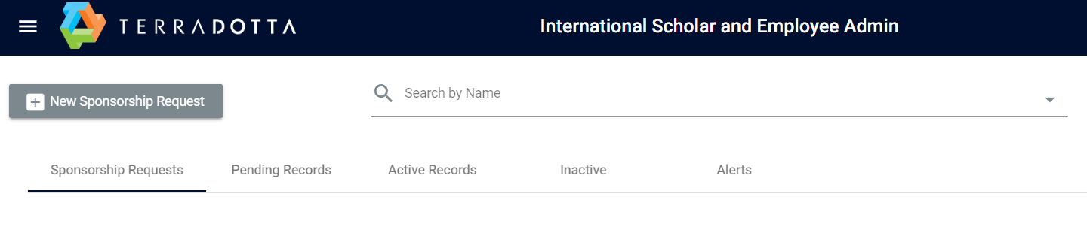

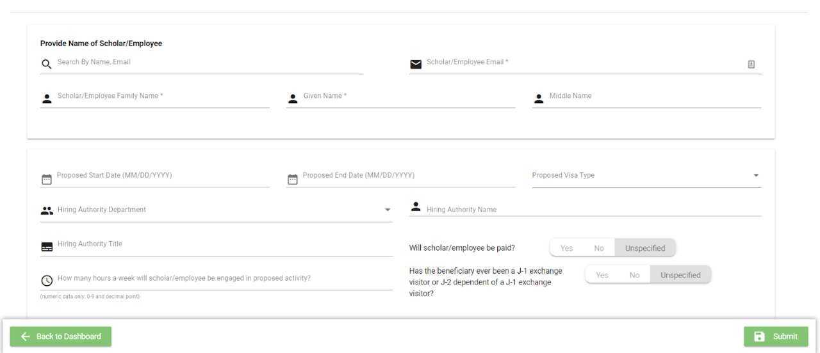**If there is no existing record in Terra Dotta**, the Department Admin can enter information into the New Sponsorship Request form. This information must be completed in one sitting, as current functionality does not allow for saving a New Sponsorship Request to be completed later. However, once submitted and before the LR accepts the request, the Department Admin a can add/update information to the form, including Documents.

*Information in the New Sponsorship Request includes, anything with an * is required:*

# H-1B Extension

From the Dashboard, go to the “ACTIVE Records” tab and click on the Beneficiary’s current record. Once in the Beneficiary’s record, to initiate an H-1B Extension, click on the H-1B Extension button located in the bottom right.

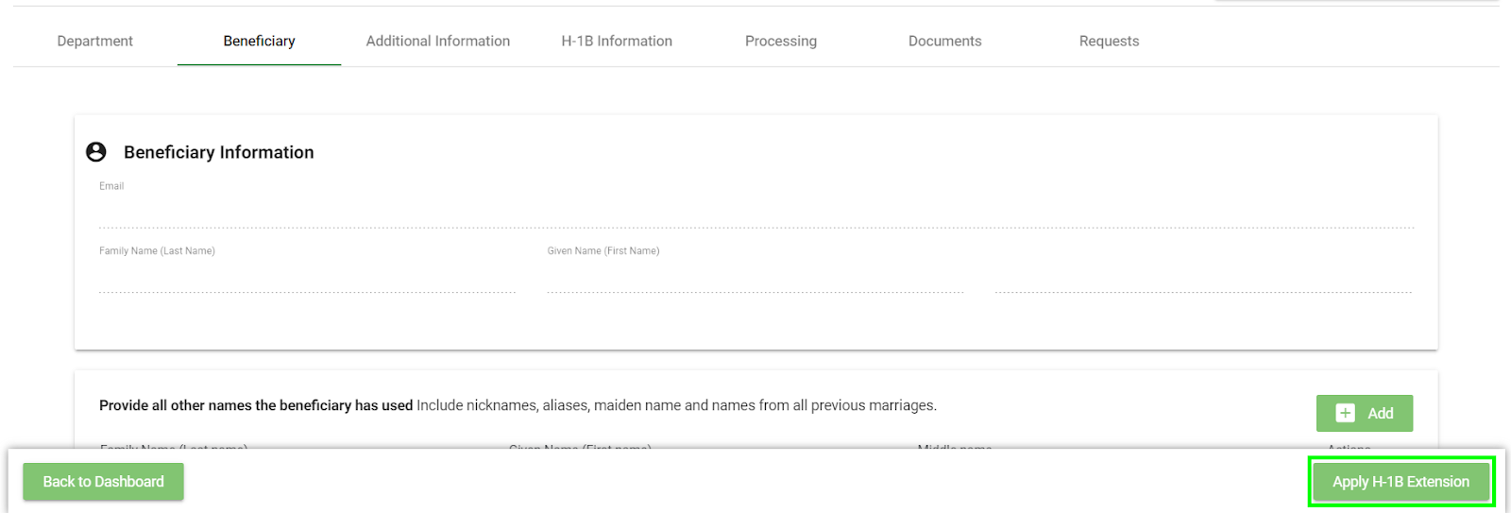

This will direct the department admin to a new H-1B Extension card, in which some of the values of the Beneficiary’s profile will be carried over from the original H-1B Request. All fields in the profile are now open for editing. Update any departmental information as needed for the H-1B Extension. **This includes salary and H-1B term dates**.

The new H-1B Extension card can be found in the **Pending Records** tab of the Admin dashboard until it has been processed and moved to Active Records.

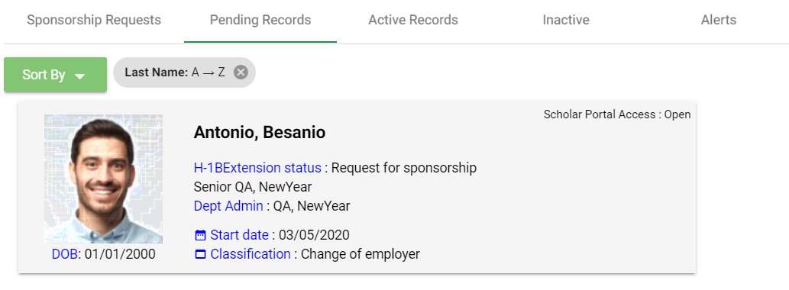

**Note**: You may save any information and come back to the Extension process later if needed. If any information has been changed, make sure to click on the Save button located at the bottom of the page for the H-1B Extension Request. The process is identical to creating an initial H-1B Request.

Once the information has been entered load the LR 418 H-1B Departmental Request Packet to the **Documents** Tab continue to complete other requested items on the Departmental Checklist. Once all the Departmental forms and letters are completed and uploaded check that the Beneficiary has also completed and loaded their documents. If they confirm, then the file is ready for LR processing, **click on the Submit to ISSS Admin button** located in the upper right corner of the Beneficiary Profile.

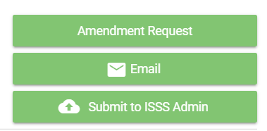

# H-1B Amendment Request

This process can be initiated by either the Departmental Admin or LR. PLEASE EMAIL [christene.cooper@uconn.edu](mailto:christene.cooper@uconn.edu) when you have completed the request.

**Creating an H-1B Amendment Request**

Begin by going to the Dashboard, then go to the “**ACTIVE**” tab and select the H-1B card that requires an amendment. Once in the Beneficiary’s active profile, click on the **Requests tab**. Under Available Requests, you will see the pencil and paper icon for Amendment.

CLICK on the Amendment icon and follow pop-up instructions. For example, if you select Yes for ‘Is salary changing?’, a new field will appear asking for the new salary and per (unit of time). You will have the options to answer the following questions:

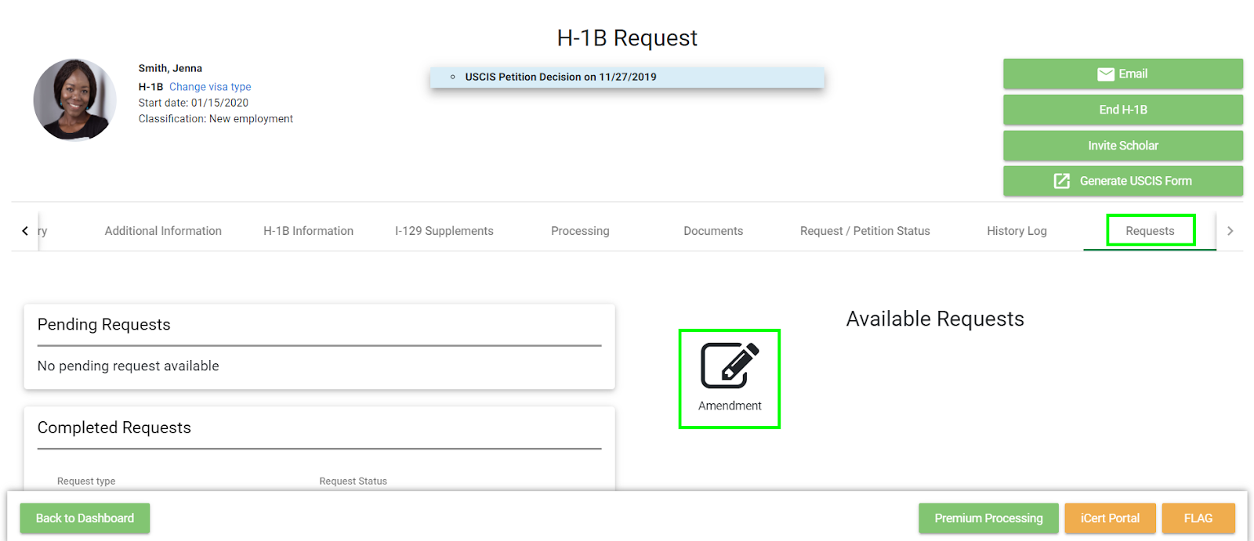

* What is the reason for requesting an amendment?
* Is the department changing?
  + What is the new department?
  + Who is the new department admin?
* Is job title changing?
  + What is the new title?
  + What is the new job description?
* Is salary changing?
  + What is the new salary?
  + Per (unit of time)
* Is the worksite location changing?
  + Worksite Address Street
  + APT/STE/FLOORAPT/STE/FLOOR Number
  + City
  + State
  + Zip Code

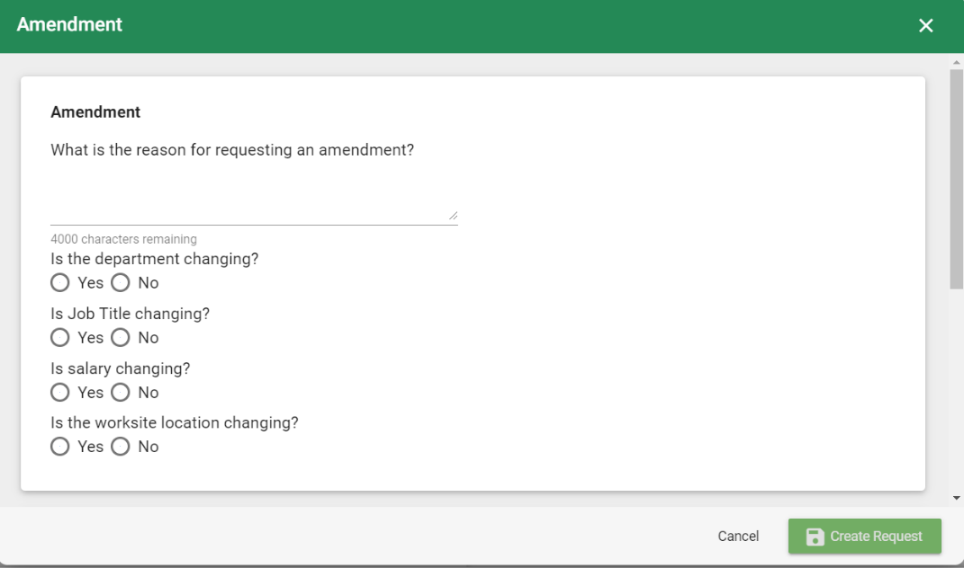

You can upload documents now, or later, after the Amendment request has been accepted by LR.

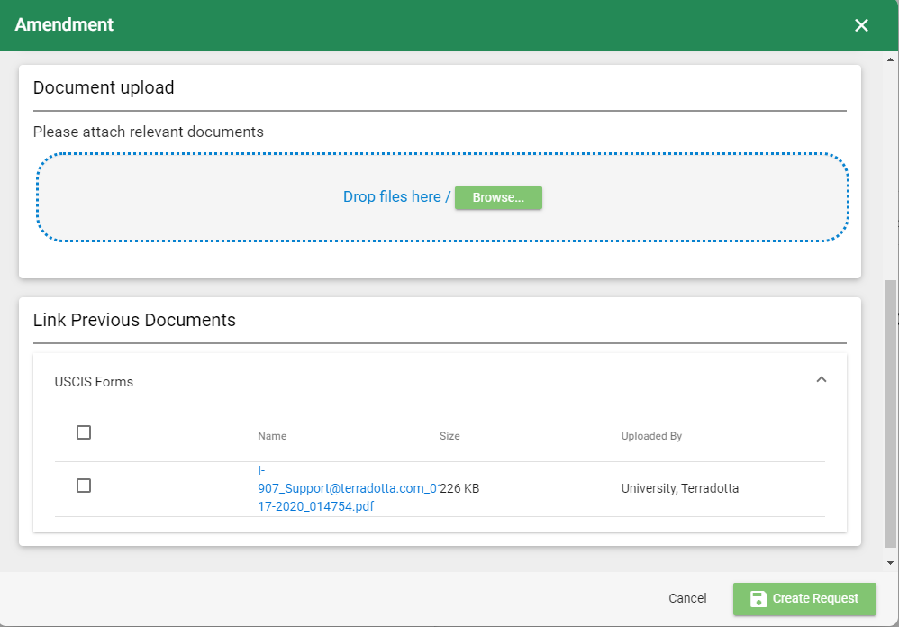

Once completed, click on the Create Request button. The new Amendment will now appear in the Beneficiary’s card under the Requests tab in the Pending Requests section.

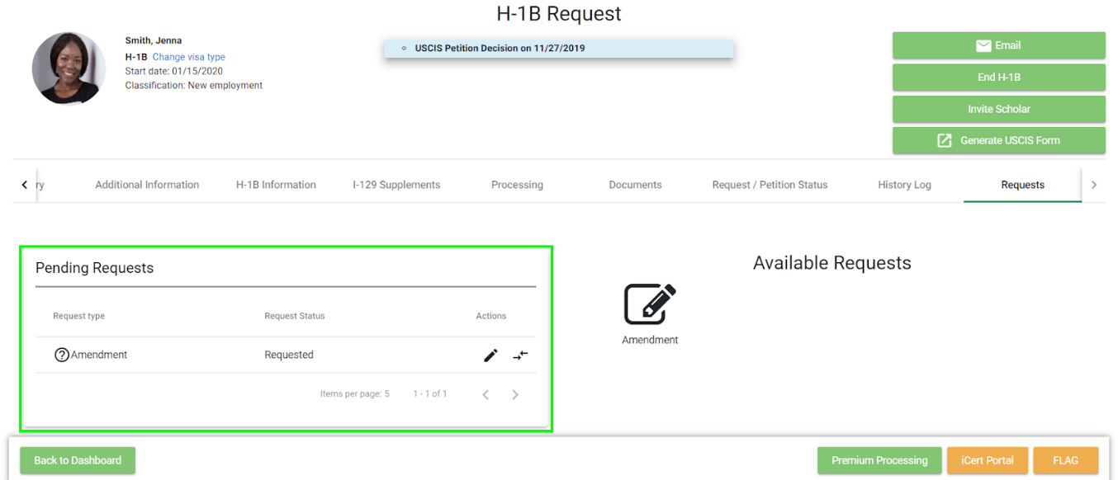

If you need to make any changes to the Pending Amendment, click on the pencil icon under the Actions column. This will display the Amendment window and from here you can make any edits.

Clicking on the opposite arrows icon will display a new screen with information on the old data and new data to allow you to review what information is being made. Any changes being made will be highlighted in yellow.

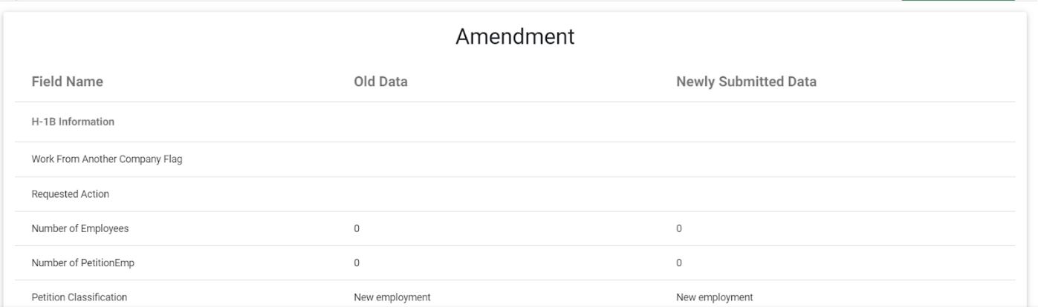

**Processing an H-1B Amendment Request**

PLEASE EMAIL [christene.cooper@uconn.edu](mailto:christene.cooper@uconn.edu) when the request is created to let her know you submitted the request.

Once the Amendment has been approved, the request will move from Pending Requests to Completed Requests on the Requests Tab. AND, a new H-1B card for the H-1B **Amendment** will be found in the **Pending Records** tab of the Dashboard.

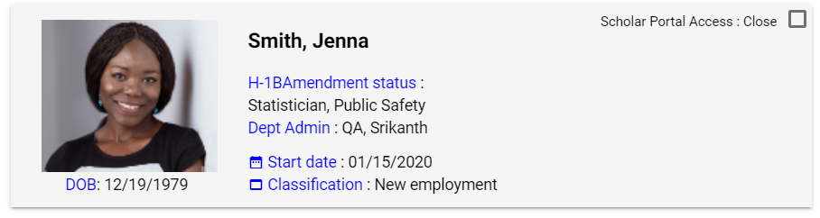

# Upload Required Documents for Departments:

For all H-1B requests, initial, extensions and amendments departments should, review and complete the information under the **Department’s TAB,** then upload the Forms and Documents listed below to the Documents Tab;

1. [**H-1B UConn Department Request PACKET - Forms (LR 418)**](https://generalcounsel.media.uconn.edu/wp-content/uploads/sites/838/2024/05/OGC_Imm_418_H-1B-Departmental_Packet_Forms_TD-2.pdf)*containing checklist at end*. (completed and signed) **upload to** **Position Description category**;
2. **OFFER LETTER**- Copies of most recent "accepted" employment offer letter(s). Offer letter should include job title, employment dates, salary, % time appointment and job duties. The new or continued hire must have an accepted offer letter extending employment at UConn.**Upload to Letters category;**
3. **Upload SUPPORTING STATEMENT:**Once completed the steps above, draft a supporting statement following this [SAMPLE Department Support Statement (LR 442)](https://generalcounsel.media.uconn.edu/wp-content/uploads/sites/838/2024/05/OGC_Imm_442_H-1B_supporting_statement_template_TD.docx) and email the Draft to [Lesley Salafia](mailto:lesley.salafia@uconn.edu) and [Christene Cooper](mailto:christene.cooper@uconn.edu). Once reviewed by the LR have the statement **signed electronically and then upload to** **Letters category. *(Due to the pandemic work from home order, we accept electronic signatures on support letters)***
4. **REQUEST FILING FEES:**follow these "[Procedures for Disbursement Vouchers for H-1B Filing Fees in Kuali Financial System (KFS)](https://generalcounsel.media.uconn.edu/wp-content/uploads/sites/838/2024/05/OGC_Imm_450_H-1B_DV_Procedures.pdf)" ***- USING KUALI FOR FEE CHECKS, NOT HuskyBuy***
5. **Upload the following to the POSITION DESCRIPTION category:**
   * **Photocopy of approved online “Recruitment & Search Application”** ***OR*** other alternative appropriate documents as evidence that the appropriate search was conducted and approved by HR and OIE.
   * **Detailed Job Description** ***AND*** for *non-audited searches* include the Position Advertisements.
   * ***If*the position will be at an “off-site” location**other than a UConn campus for either all or part of the petitioned period of employment, provide a detailed itinerary of the expected dates and times that the beneficiary will be at the off-site location as well as the expected dates and times that the beneficiary will be at UConn’s campuses.